1. Click the following link to be directed to the hour of code website

<https://studio.code.org/s/mc/lessons/1/levels/1>

1. Press play on the introductory video that is displayed on the screen after clicking the link

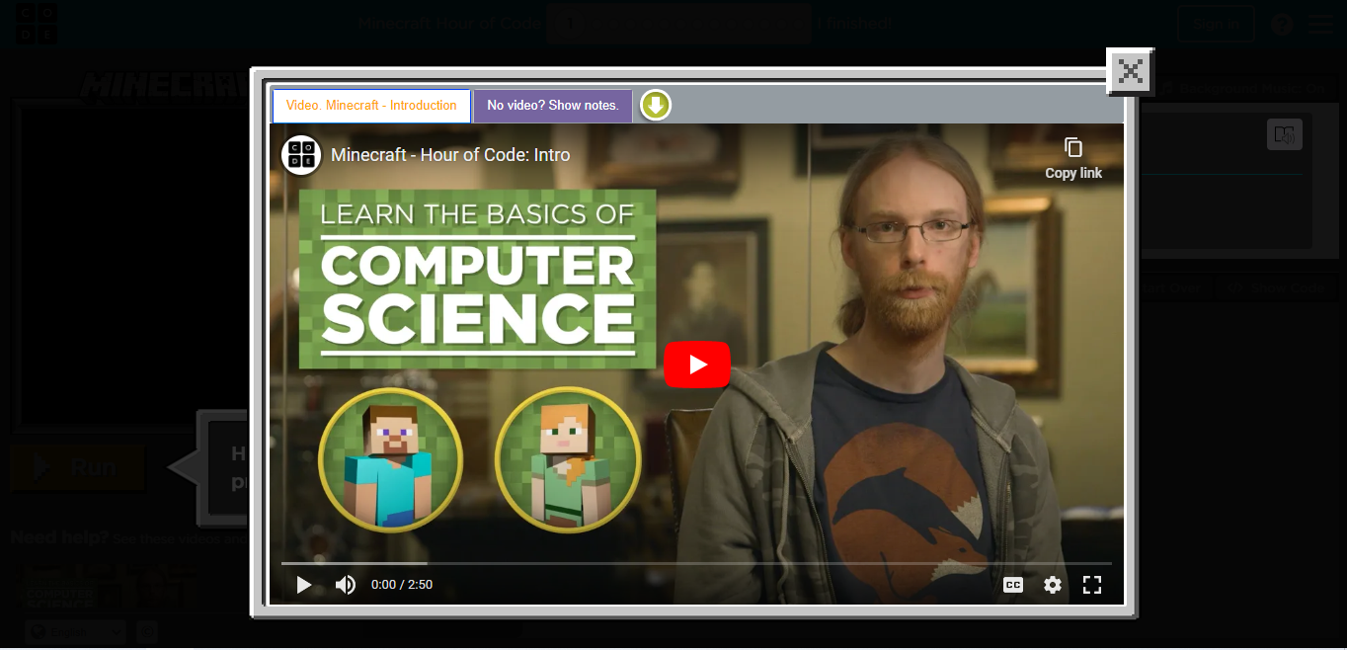

1. Select a character from the menu to get started

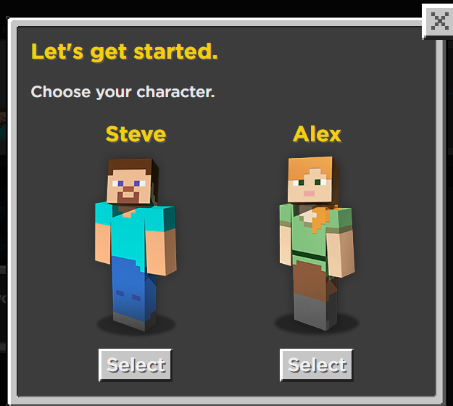

1. Follow the instructions given on screen to begin coding and making the character in the left window move and complete desired actions

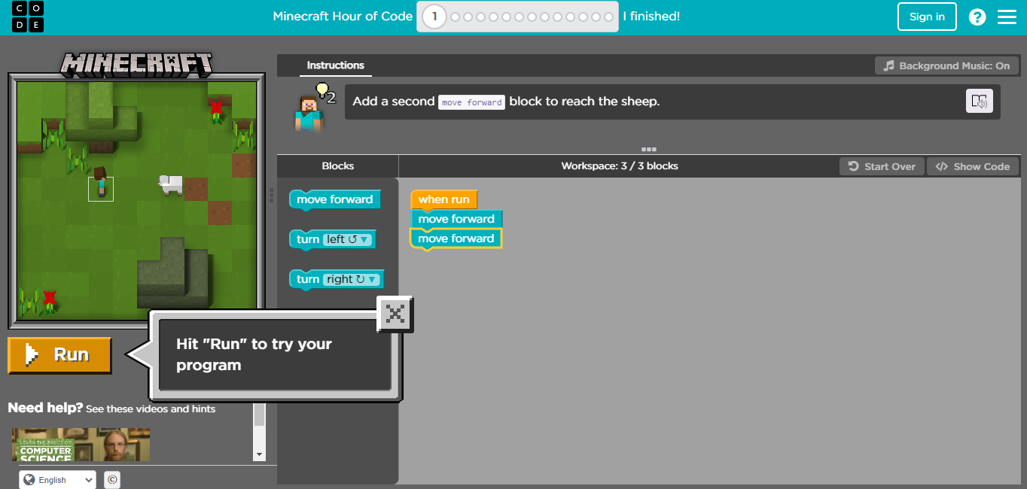

1. The image directly above also shows the completed code stack in the workspace. This code will make the character move forward two blocks to the sheep. Build this code stack and click “Run”
2. You should see this popup after each level is completed successfully

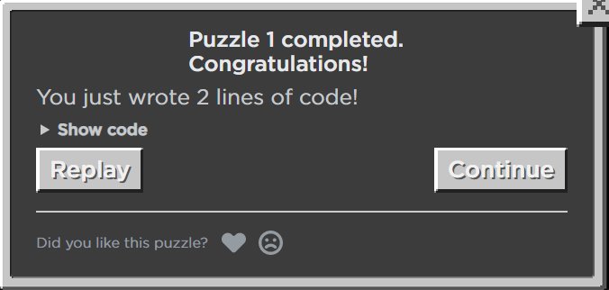

1. Click continue and move on to the next puzzle
2. Follow the instructions located directly above the workspace again and build a code stack to make you character do the desired action
3. The completed code stack for level two is as follows:

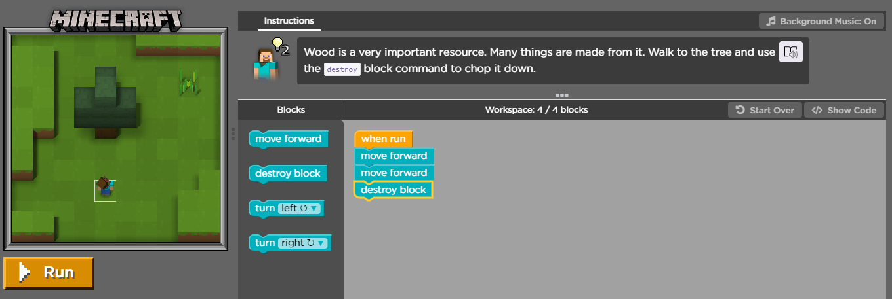

1. All of the remaining puzzles will follow the same steps as listed for the first two. Once puzzle three is started, complete the code stack to shear both sheep. The completed stack is shown below

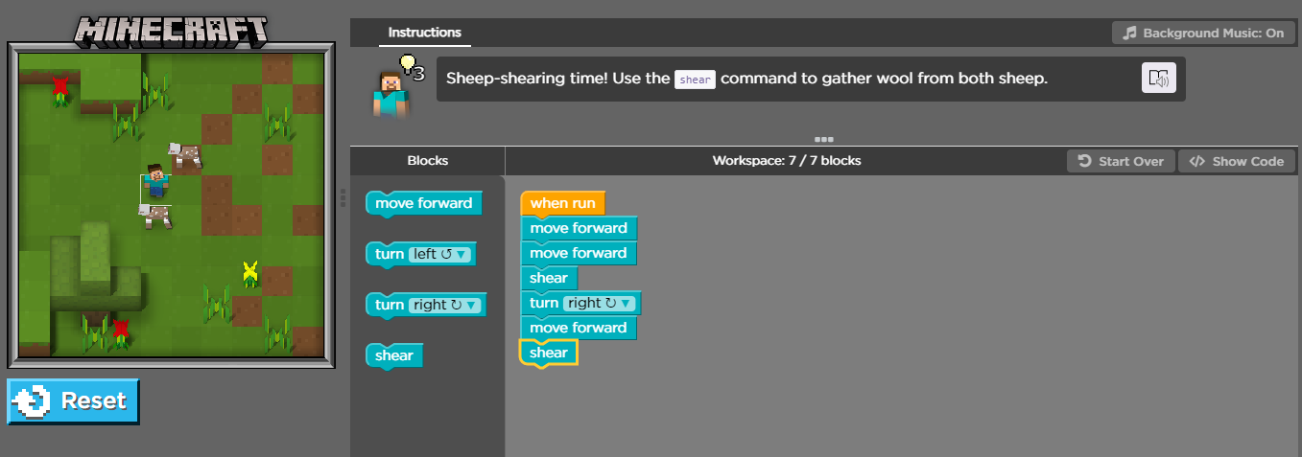

1. The completed code stack for puzzle 4 is shown below

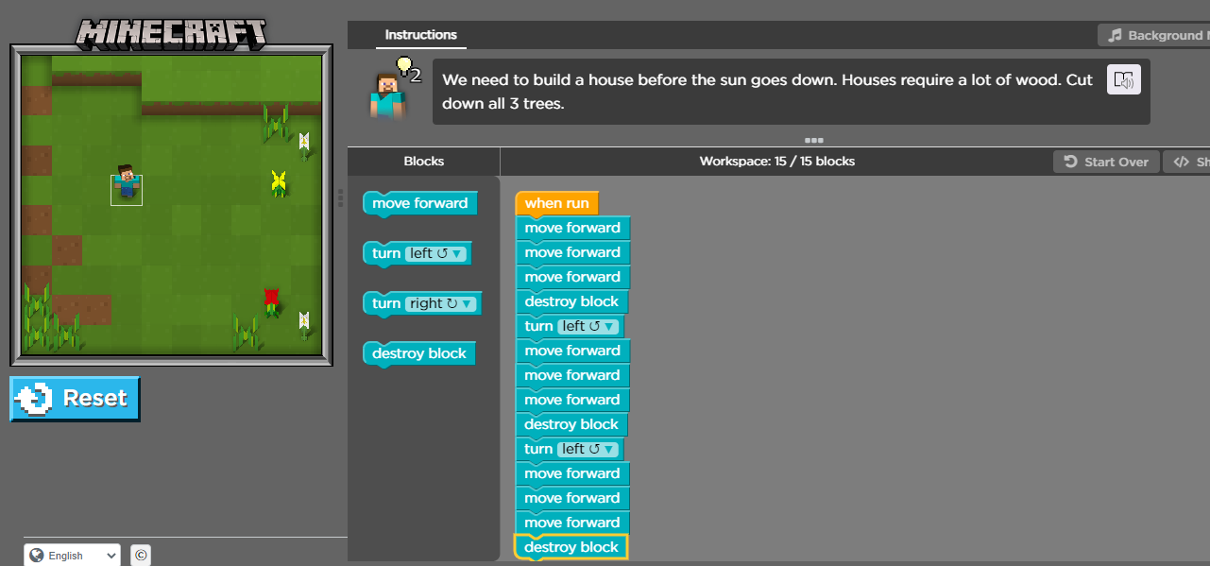

1. When you get to puzzle 5 another video will be displayed on the screen. Watch this video then begin creating the code stack for the problem

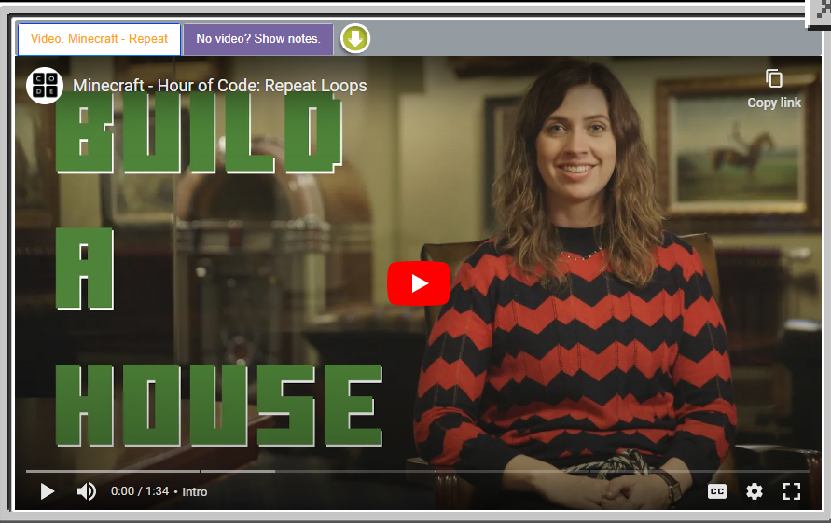

1. The image below shows the completed code stack for puzzle five using a loop

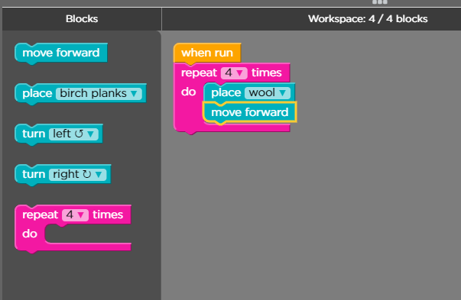

1. Puzzle 6 will display a popup when you get to it

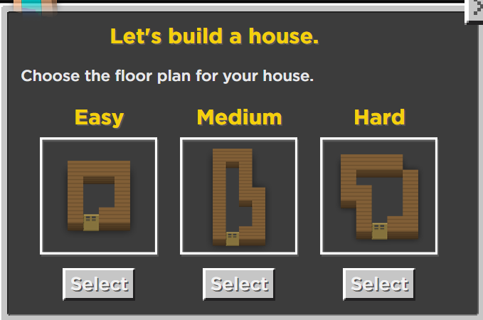

1. Please select your desired floor plan as shown in the image above, we will be adding code to copy this layout in the next puzzles
2. The completed code stack for puzzle 6 on easy difficulty is shown below

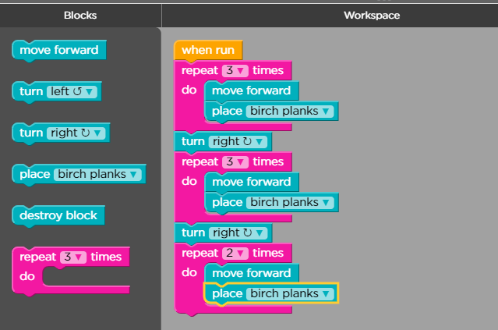

1. Move on to puzzle 7 and complete it. The completed code stack for puzzle 7 is shown below.

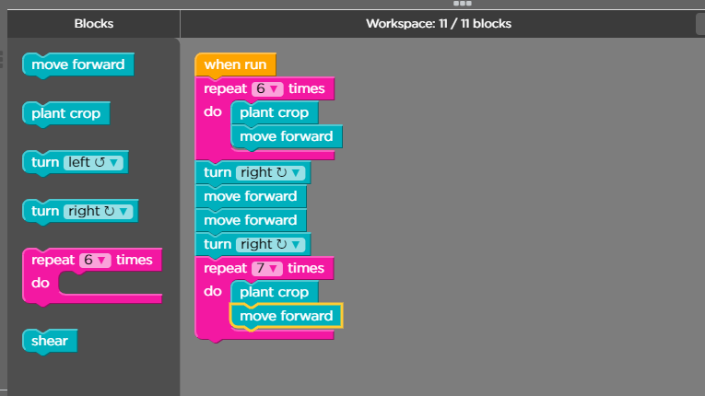

1. The completed code stack for puzzle 8 is shown below

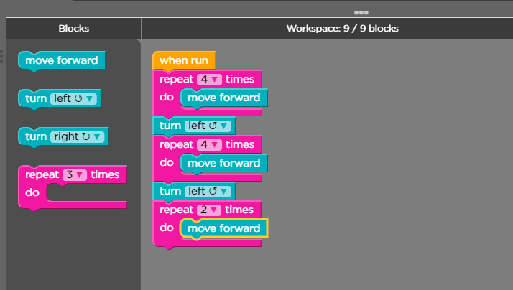

1. The completed code stack for puzzle 9 is shown below

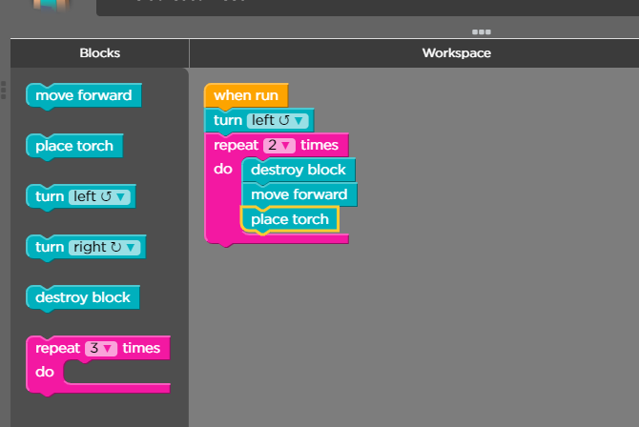

1. The completed code stack for puzzle 10 is shown below

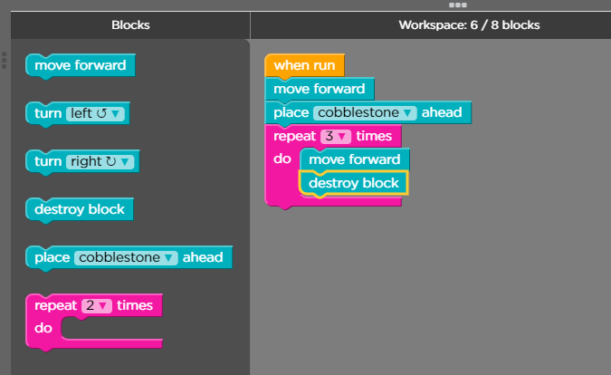

1. When you come to this video after puzzle ten please watch then complete puzzle 11

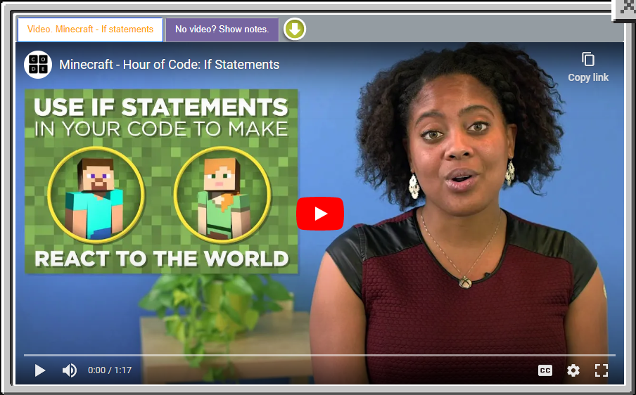

1. The completed code stack for puzzle 11 is below

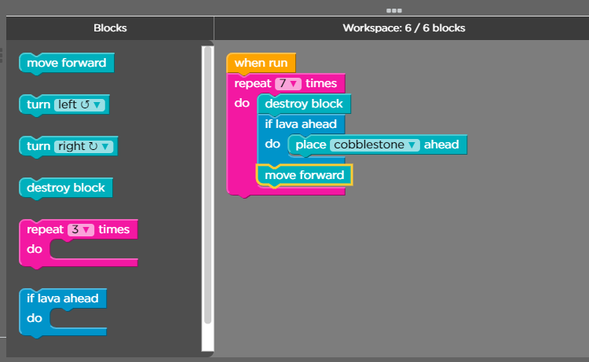

1. The completed code stack for problem 12 is shown below

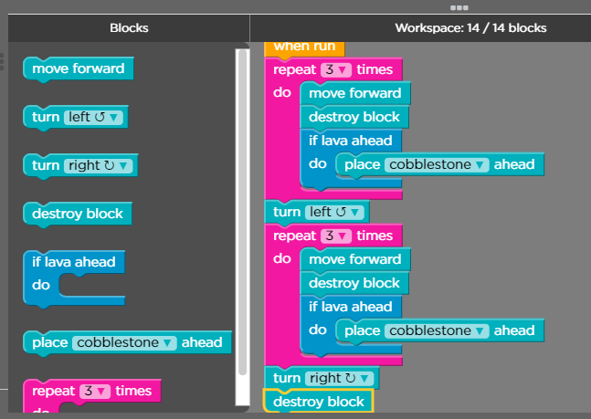

1. The completed code stack for problem 13 is shown below

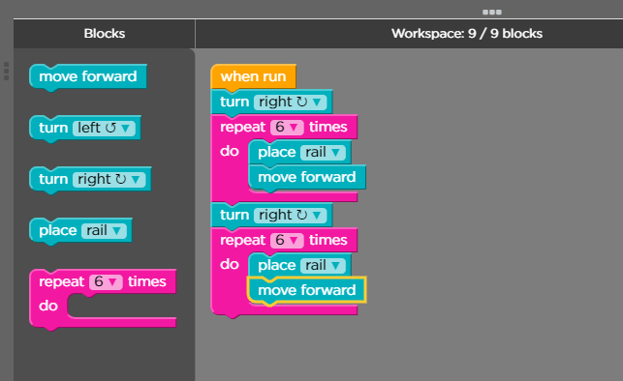

1. Please watch the suggested video prior to starting puzzle 14

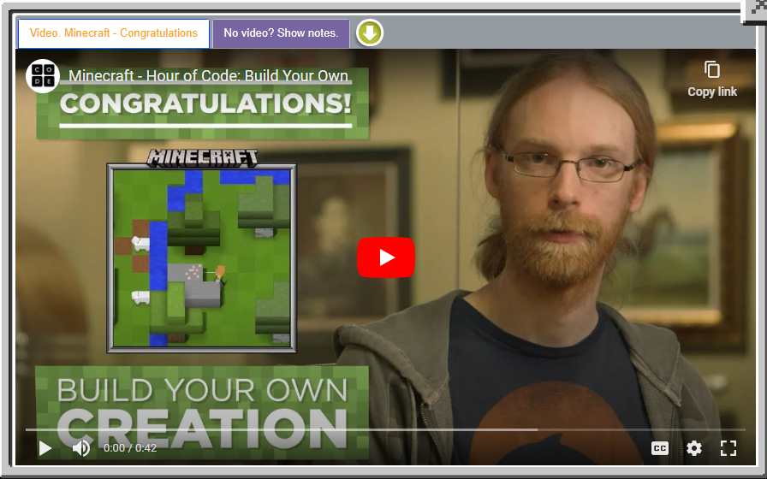

1. The tutorial is now complete and students can feel free to build their own creations!